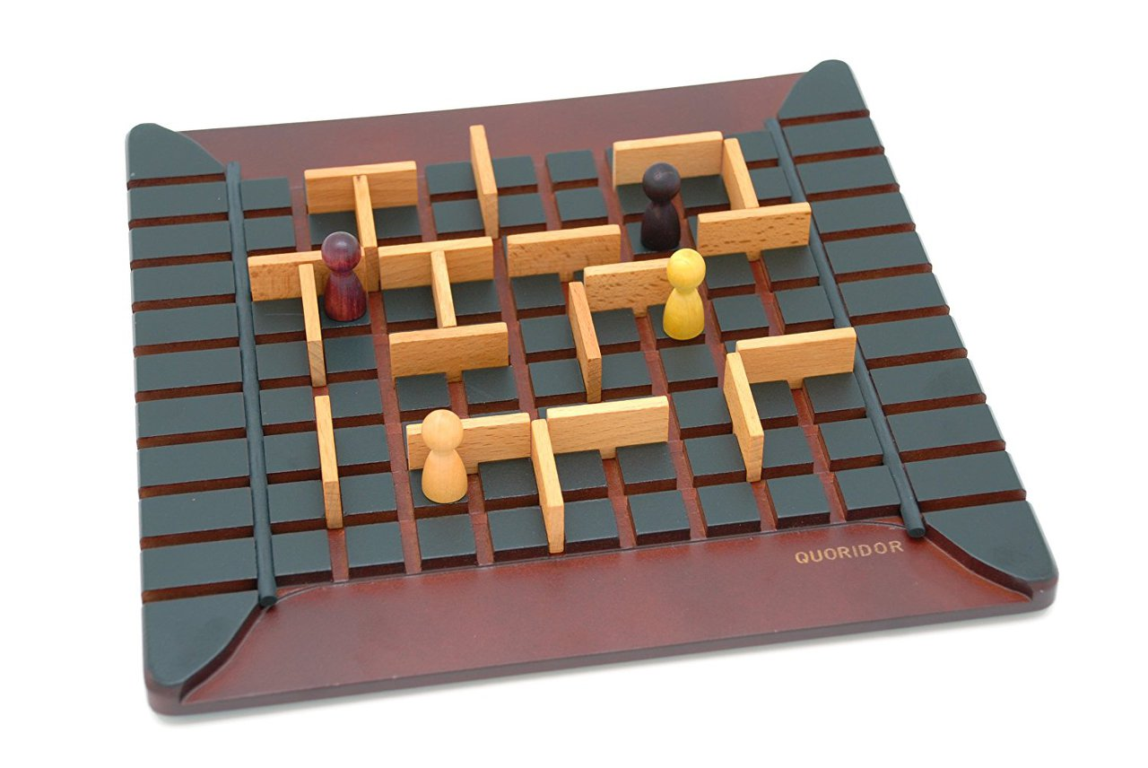

**Anido**

Document version number *(v1.0.0)*

Written by *(Team GOGUMA)*

Point of contact *(goguma1000@ajou.ac.kr)*

Date of publishing

2023.03.28

**Group members**

| **Name** | **Role** | **Main contributions** |
| --- | --- | --- |
| Dae Yong Kim | Game Server | Game server development |
| Choi Dong Ho | Game Client | Game client development |
| Lee Seung Woo | Game Server | Game server development |
| Han Song Heon | Game Client | Game client development |

**Document history**

| **Revision** | **Date** | **Name** | **Comment** |
| --- | --- | --- | --- |
|  | 23.03.28 | GOGUMA | GDD First version |
|  |  |  |  |

# 

# 

# 

# 

# 

**Table of contents**

**OverView 4**

**Game controls 6**

**Technological requirements 6**

**Title/start screen 7**

**Game flowchart 8**

**Loading screen 8**

**Game camera(s) 8**

**HUD system 8**

**Player character(s) 9**

**Player metrics 9**

**object sets 10**

**Stage theme 10**

**Music and SFX 10**

# 

# OverView

This game is a casual strategy board game that can be enjoyed by anyone. The original prototype of this game is the famous board game, Quoridor, which is popular worldwide. In this game, players select a variety of cute animal characters and game boards with adorable themes to play. The objective of the game is simple: be the first to reach the destination.

In each turn, players can choose to perform one of two actions. The first action is to move one space on the game board, which can help players get closer to their destination. The second action is to block the opponent's path by placing obstacles on the game board.

By strategically blocking the opponent's path, players can prevent them from reaching the destination before they do. The key to winning this game is to make smart choices and select the right strategy at the right time.

Since each decision can have a significant impact on the outcome of the game, players must plan carefully and develop a winning strategy. This game can be played by two or four players, and it requires strategic thinking and quick decision-making to succeed.

Genre: Strategy board game, casual.

Age: All ages.

Number of players: 2 or 4.

Summary :

* Who, What, How?
  + Who - Tell who this game is for. What ages?   
    - For all
  + What - Provide a game summary. What is this game about?

- In each turn, players can choose to perform one of two actions.

The first action is to move one space on the game board, which can help players get closer to their destination.

The second action is to block the opponent's path by placing obstacles on the game board.

* + How - Explain how this game will be awesome. Mention key selling points like new/novel mechanics or gameplay features.

- Simple game rules make it easy for anyone to play

- Two-player strategy allows for a wide range of difficulty and playability

* Explain what platform this fame is for. Will it feature multiplayer capability? Does it have any technical requirements?

- PC platform

* Provide short descriptions of gameplay types (stealth, battle arena, driving, flying, shooting, strategy, and so on) in the game.
* Casual Strategy Board Game
* By strategically blocking the opponent's path or moving own player, players can prevent the opponents from reaching the destination before they do. The key to winning this game is to make smart choices and select the right strategy at the right time.
* Since each decision can have a significant impact on the outcome of the game, players must plan carefully and develop a winning strategy.
* Explain the conditions for winning the game and the conditions for losing it.
* Winning condition is, if your pieces reach the opposite end of the board before your opponent's.

**Story overview (Not applicable)**

# **Game controls**

Mouse clicks - click on specific tiles to move pieces or set up obstacles

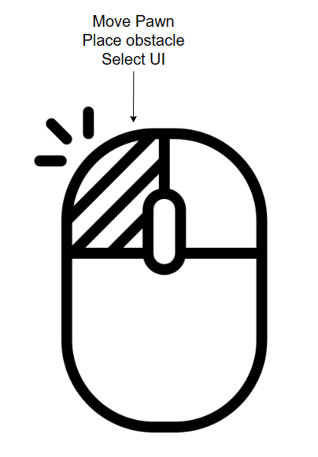

# **Technological requirements**

* What development tools will this game use?

- Git, unity, Spring Tool suite 4, visual studio, Jira, IntelliJ

* What is the target platform?

- PC(OS : window 10)

* What design tools will this game use? List level creation and scripting tools used.

- Photoshop, Illustrator,Unity Asset Store

* What are the proposed tools for cheats? Include controls for level, invulnerability, camera, and other gameplay related cheats.

- Managing coordinate information between players on the server

* For PC and mobile games, include a section covering the target specs of the device needed to run the game. This would list things like the amount of RAM, minimum CPU speed, minimum graphical abilities, required peripherals and so on.
* 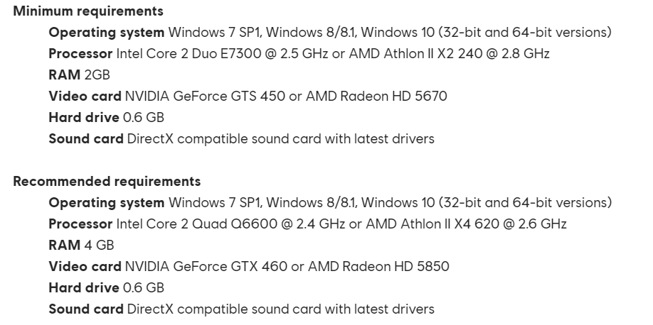

# **Title/start screen**

…

# **Game flowchart**

# 

# **Loading screen**

some background images with each player’s status with player profile

# **Game camera(s)**

Fixed 3D Top view

# **HUD system**

Number of available obstacles (remaining walls), time left on player’s or opponent's turn

When a player attempts to move a pawn, the space where the pawn can move lights up.

If a player attempts to place an obstacle, the space where the obstacle cannot be placed will light up.

# **Player character(s)**

animal characters

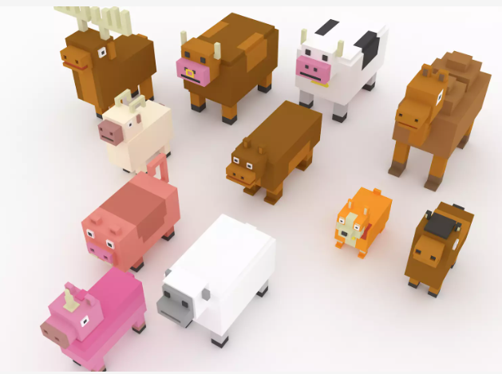

# **Player metrics**

Each character has movements that match their unique animal traits

**Player skills (Not applicable)**

**Combat(Not applicable)**

**Power-ups/state modifiers(Not applicable)**

**Scoring (if applicable)** - Assign point values to actions and explain what happens when players reach them. How do players earn bonuses in the game (like chaining or combos)?

* Leader board setup - What does it look like? What stats are being tracked?
* Achievements - What achievements are available and how are they earned? List them and provide images for badges if applicable.

# **object sets**

When the game starts, there are a certain number of obstacles available.

**Game progression outline (Not applicable)**

**World overview/level select/navigation screen (Not applicable)**

**Universal game mechanics (Not applicable)**

**Game levels(Not applicable)**

# 

# Stage theme

1. spring

The season on this map is spring

1. fall

The season on this map is fall

**General enemy rules(Not applicable)**

**Level specific enemies(Not applicable)**

**NPCs (Not applicable)**

# 

# **Music and SFX**

Casual background music.

Casual SFX